Mrs. International 2003 - Coverage
Photos courtesy of Mrs. International pageant and the Mrs. International delegates.
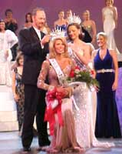
The 17th annual Mrs. International Pageant was held on Saturday, September 6, 2003, at the spectacular Louise Mandrell Theater in Pigeon Forge, Tennessee. The will once again be hosted by none other than the genial Bob Eubanks (you know him from "The Newlywed Game").
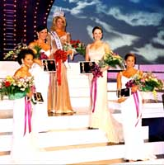
The new Mrs. International 2003 is Michelle Fryatt, who competed as
Mrs. Nevada. Michelle also won the preliminary aerobic wear award.
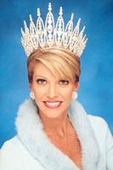
The first runner up was Mrs. District of Columbia Michelle Carolla; second runner up was Mrs. Indiana Lacey Mervine; third runner up was Mrs. Oregon Mary Nelson; and fourth runner up was Mrs. Ohio Cami Gooding.
The remaining semifinalists were : Mrs. Denmark Sara Pirok, Mrs. New Hampshire Oneta Bobbet, Mrs. Virginia Jacqeline Arnold, Mrs. Maryland Nikki Karl, and Mrs. Utah Melinda Clarkson-Haynes.
Mrs. International 2003 Contestants
  Alabama  Andrea Frazier |   Alaska  Lucinda Harwood |   Arizona  Julie Quijada |   Arkansas  Rebecca Chandler Fisher | 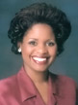  California  Chyrissee Kimberly Lee
  Canada  Monica Zeniuk |   Colorado  Sheree Frede |   Connecticut  Agnes Pireh |   Denmark  Sara Pirok  Semifinalist '03 |   Dist. of Columbia  Michelle Carolla  1st RU '03
  Florida  Christine Mowry |   Georgia  Kim Vaughn |   Hawai'i  Cesci Wong |   Idaho  Janice Jarzabek |   Illinois  Amy Yount
  Indiana  Lacey Mervine  2nd RU '03 |   Iowa  Heather Hulen |   Kansas  Debi Moore |   Kentucky  Rhonda Arena |   Louisiana  Latonya Sibley
  Maine  Jennifer Weber |   Maryland  Nikki Karl  Semifinalist '03 |   Massachusetts  Kathy Lauer |   Michigan  Michelle Velzen |   Minnesota  Holly Ernst
  Mississippi  Shonia Martin |   Missouri  Georgiann Manz |   Montana  Lorinda Smith |   Nebraska  Cynthia Kaup |   Nevada  Michelle Fryatt  Mrs. International '03
  New Hampshire  Oneta Bobbett  Semifinalist '03 |   New Jersey  Oneta Bobbett |   New Mexico  Elizabeth Burris |   New York  Ginny Paskiewicz |   Nigeria  Blessing Ngenge
  North Carolina  Elizabeth Romer |   North Dakota  Kristi Larkin |   Ohio  Cami Gooding  4th RU '03 |   Oklahoma  Debbie Westman |   Oregon  Mary Nelson  3rd RU '03
  Pennsylvania  Jodi Cessna |   Rhode Island  Lori Grover |   South Carolina  Mary Snipes Phillips |   South Dakota  Olivia Weter |   Sri Lanka  Prashanthi Perimpanayagam
  Tennessee  Tracy Pointer |   Texas  Candice Barsh | 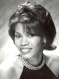  Trinidad & Tobago  Terrianne Lord-Small |   Utah  Melinda Clarkson-Haynes  Semifinalist '03 |   Virginia  Jacqeline Arnold  Semifinalist '03
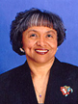  Washington  Cherry Rachal |  |   West Virginia  Kris Richmond |  | 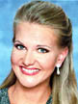  Wisconsin  Kimberly Erickson-Nicholes

